Table names in Metabase are as follows,

* + cr_customers
  + cr_employees
  + cr_offices
  + cr_orderdetails
  + cr_orders
  + cr_payments
  + cr_productlines
  + Cr_products

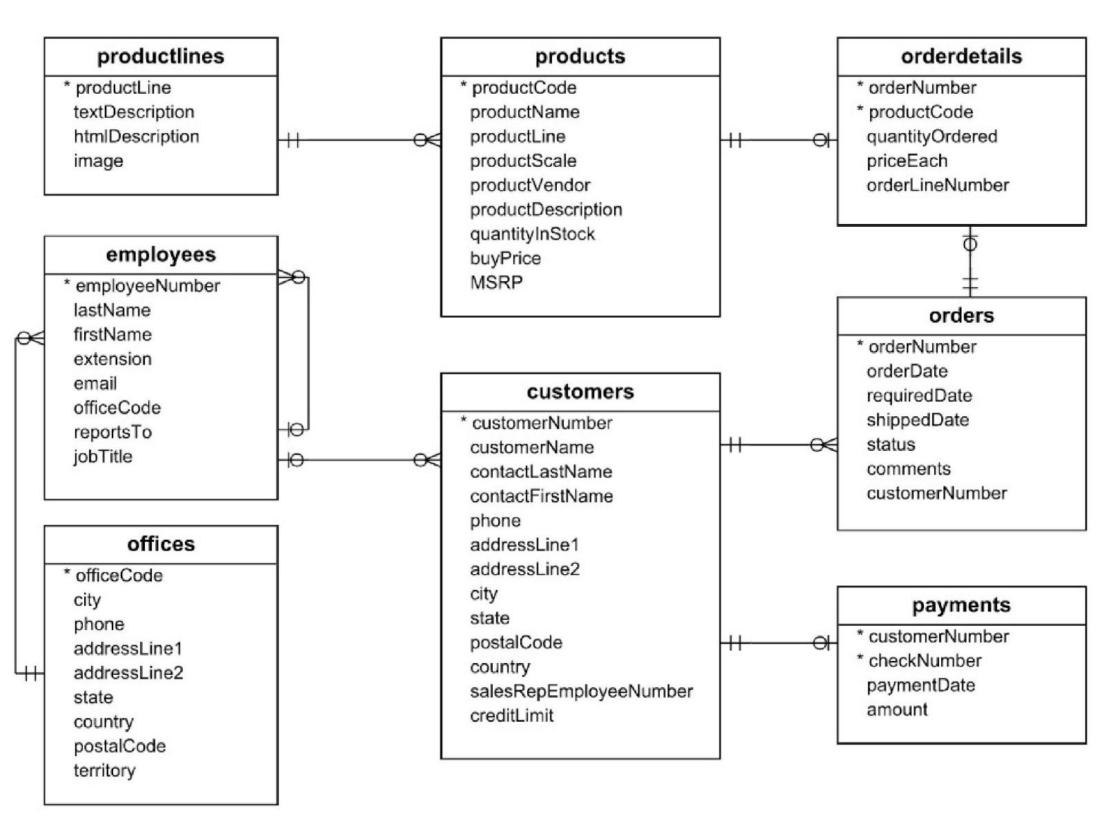

### Question 1

1/1 point (graded)

How many orders of status shipped were shipped on or later than the required date?

**Skills**: Comparing columns in the [WHERE clause](https://lms.codinginvaders.com/courses/course-v1:CodingInvaders+DATEST+1/course/#block-v1:CodingInvaders+DATEST+1+type@sequential+block@60e03ce307d6417aacf691793c50c707)

ANS-

select count(*) from cr_orders

where (shippedDate-requiredDate)>=0 and status="Shipped"

### Question 2

1/1 point (graded)

The average MSRP of the productline 'Motorcycles' is 97.18, and the average MSRP of the productLine‘ Classic Cars' is 118.02

Find out the product code for products mentioned above with a quantity more than equal to 1000. Extend the SQL query to filter 'Motorcycles' with greater than its average price and ‘Classic Cars' with less than its average price.

Additionally, sort the results based on “MSRP” (highest to lowest) and “quantityInStock” (lowest to highest).

Share the product code of the 3rd result from the top.

**Skills**: [WHERE](https://lms.codinginvaders.com/courses/course-v1:CodingInvaders+DATEST+1/course/#block-v1:CodingInvaders+DATEST+1+type@sequential+block@60e03ce307d6417aacf691793c50c707https://lms.codinginvaders.com/courses/course-v1:CodingInvaders+DATEST+1/course/#block-v1:CodingInvaders+DATEST+1+type@sequential+block@60e03ce307d6417aacf691793c50c707), [ORDER BY](https://lms.codinginvaders.com/courses/course-v1:CodingInvaders+DATEST+1/courseware/f213eb540fbc49bbbba3160cafba5a11/0948b0c6f3d14c2f9d98ff91a240c844/?activate_block_id=block-v1%3ACodingInvaders%2BDATEST%2B1%2Btype%40sequential%2Bblock%400948b0c6f3d14c2f9d98ff91a240c844)

**Ans-**

select productCode,productLine from cr_products

where quantityInStock>=1000 and productLine in ("Motorcycles","Classic Cars") and (MSRP>97.18 or MSRP<118.02)

### Question 3

**2/2 points (graded)**

**Find out the product's revenue (based on MSRP) based on each productScale.**

**revenue = quantity * MSRP**

**Which ProductLine and ProductScale have the highest revenue?**

**Skills:** [**GROUP BY**](https://lms.codinginvaders.com/courses/course-v1:CodingInvaders+DATEST+1/courseware/af7b4de2e9ae4842bf70ceaf35575e4f/ca49c9b4cab040ce9b337dc999ac8907/?activate_block_id=block-v1%3ACodingInvaders%2BDATEST%2B1%2Btype%40sequential%2Bblock%40ca49c9b4cab040ce9b337dc999ac8907)

**Ans-**

select productLine,productScale,sum(quantityInStock*MSRP) as Revenue from cr_products

group by productLine,productScale order by Revenue desc

### 

### 

### 

### 

### 

### 

### 

### 

### 

### Question 4

1/1 point (graded)

Write an SQL query that generates the following output. Additionally, sort the results to get the highest profit on top.

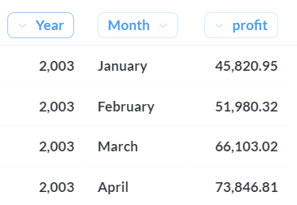

What is the Year and Month which has the highest profit?

Enter the answer like “January 2004”

**Skills**: [GROUP BY](https://lms.codinginvaders.com/courses/course-v1:CodingInvaders+DATEST+1/courseware/af7b4de2e9ae4842bf70ceaf35575e4f/ca49c9b4cab040ce9b337dc999ac8907/?activate_block_id=block-v1%3ACodingInvaders%2BDATEST%2B1%2Btype%40sequential%2Bblock%40ca49c9b4cab040ce9b337dc999ac8907), [INNER JOIN (3 tables)](https://lms.codinginvaders.com/courses/course-v1:CodingInvaders+DATEST+1/course/#block-v1:CodingInvaders+DATEST+1+type@sequential+block@0aa78eca63084e329af78f0fb2a7eb8b), [Date Functions](https://lms.codinginvaders.com/courses/course-v1:CodingInvaders+DATEST+1/jump_to/block-v1:CodingInvaders+DATEST+1+type@sequential+block@d11a0404e0a1453eb5e2db6684892113)

**Note:** If you find difficulty solving this question please revisit the concept from the LMS

ANS-select year(a.orderDate) as Year,monthname(a.orderDate) as Month,sum((b.priceEach-p.buyprice)*b.quantityOrdered) as profit from cr_orders a inner join cr_orderdetails b

on a.orderNumber=b.orderNumber inner join cr_products p on p.productCode=b.productCode group by Year,Month order by profit desc

### Question 5

1/1 point (graded)

Which product is not ordered yet?

**Skills**: [LEFT/RIGHT JOIN (2 tables)](https://lms.codinginvaders.com/courses/course-v1:CodingInvaders+DATEST+1/course/#block-v1:CodingInvaders+DATEST+1+type@sequential+block@0aa78eca63084e329af78f0fb2a7eb8b)

**Note:** If you find difficulty solving this question please revisit the concept from the LMS.

Share the product code.

ANS-select p.productCode from cr_products p left join cr_orderdetails o on p.productCode=o.productCode where o.productCode is null

### Question 6

1/1 point (graded)

In the above question, if you have used, let's say, Table A and Table B., While JOINing the table, you have to keep Table A on the left and Table B on the right. And if you have used LEFT JOIN in the operation, as shown below.

SELECT *

FROM Table A a

LEFT JOIN Table B b

ON a.id = b.id

Now, if you keep Table B on the left and Table A on the right, what JOIN be appropriate to get the same answer?

SELECT *

FROM Table B b

???? JOIN Table A a

ON a.id = b.id

**Skills**: [LEFT/RIGHT JOIN (2 tables)](https://lms.codinginvaders.com/courses/course-v1:CodingInvaders+DATEST+1/course/#block-v1:CodingInvaders+DATEST+1+type@sequential+block@0aa78eca63084e329af78f0fb2a7eb8b)

**Note:** If you find difficulty solving this question please revisit the concept from the LMS.

ANS-RIGHT

### Question 1

1/1 point (graded)

find out the % of revenue generated from each customer for their respective country.

What is the % of revenue from “Mini Gifts Distributors Ltd”?

Consider the following CTE example of the query extending the query to get the required output.

**Note**: “**Car Retailer**” database

WITH customerorders

AS (SELECT country,

c.customernumber,

customername,

*Sum*(amount) AS 'customerOrderValue'

FROM cr_payments p

JOIN cr_customers c

ON p.customernumber = c.customernumber

GROUP BY country,

customernumber,

customername)

SELECT *

FROM customerorders a

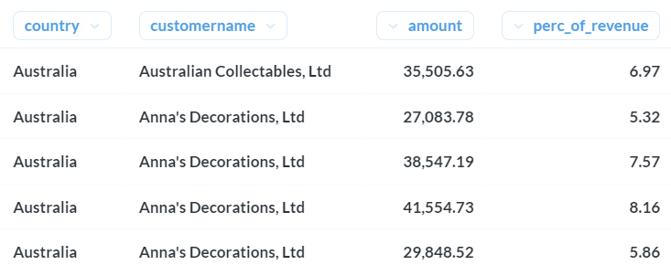

What is the % of revenue from “Royal Canadian Collectables, Ltd.”?

ANS-WITH customerorders

AS (SELECT country,

c.customernumber,

customername,

Sum(amount) AS 'customerOrderValue'

FROM cr_payments p

JOIN cr_customers c

ON p.customernumber = c.customernumber

GROUP BY country,

customernumber,

customername)

SELECT a.country,

customername,

customerordervalue,

customerordervalue / countrywiserevenue * 100 AS 'perc_of_revenue'

FROM customerorders a

JOIN (SELECT country,

Sum(customerordervalue) AS 'countryWiseRevenue'

FROM customerorders

GROUP BY country) b

ON a.country = b.country

ORDER BY country

## Business Case-

In this business case, an extract of a Paper company’s database is available to analyze the company's business operations. The company has three products (Standard, Gloss, and Poster paper) and several agents to support the business through various web channels such as (Facebook, Adwords, Twitter direct, etc.) The company uses different channels to promote its products, and different accounts connect to the company via these channels to place orders. Such data is also logged in the database.

## Tables -

**1. Table name -** pm_accounts

| **Column_name** | **Description** |
| --- | --- |
| id | Unique ID of the account |
| name | Name of the account |
| website | Website URL of the client |
| lat | Latitude of the office address |
| long | Longitude of the office address |
| primary_poc | Primary Spoc Person |
| agent_id | Associated agent ID |

**2. Table name -** pm_agents

| **Column_Name** | **Description** |
| --- | --- |
| agent_id | Unique ID of agent |
| agent_name | Name of the agent |
| location | Serving location of the agent |

**3. Table name -** pm_orders

| **Column_Name** | **Description** |
| --- | --- |
| id | Order ID |
| account_id | Associated account ID |
| occurred_at | Date and time of the order |
| standard_qty | Quantity of standard paper |
| gloss_qty | Quantity of gloss paper |
| poster_qty | Quantity of poster paper |
| total | Total quantity ordered |
| standard_amt_usd | Sales of standard paper ($) |
| gloss_amt_usd | Sales of gloss paper ($) |
| poster_amt_usd | Sales of poster paper ($) |
| total_amt_usd | Total Sales amount |

**4. Table name -** pm_web_events

| **Column_Name** | **Description** |
| --- | --- |
| event_id | Web event identifier |
| account_id | Associated id of the account |
| occuured_at | Date and time of the event |
| channel | Channel name of the connection. |

### Question 2

1/1 point (graded)

How many events were conducted via Facebook and Twitter in January 2015?

ANS -14

select count(*) from pm_web_events where channel in("Facebook","twitter") and Month(occurred_at)=1 and year(occurred_at)=2015

### Question 3

1/1 point (graded)

How many accounts are operated by the agents of the ‘Northeast’ location?

Ans -106

select count(*) from pm_accounts a inner join pm_agents b on a.agent_id=b.agent_id where location ="Northeast"

### Question 4

1 point possible (graded)

Find out the accounts-to-agents ratio for the accounts operated by the agents of the ‘Midwest’ location.

ANS-5.33

select count(distinct id)/count(distinct b.agent_id) from pm_accounts a inner join pm_agents b on a.agent_id=b.agent_id where location="Midwest"

### Question 5

1/1 point (graded)

Select the account name for which no orders have been placed.

ANS-Goldman Sachs Group

select * from pm_accounts a left join pm_orders b on a.id=b.account_id where b.order_id is NULL

### Question 6

1/1 point (graded)

Select the account that made the highest total sales between 12-Jan-2014 to 15-Nov-2015.

ANS

SELECT a.NAME, SUM(total_amt_usd) AS 'Total_amount'

FROM pm_orders AS o

INNER JOIN pm_accounts AS a

ON o.account_id = a.id

WHERE o.occurred_at BETWEEN '2014-01-12' AND '2015-11-15'

GROUP BY a.NAME

ORDER BY Total_amount DESC;

### Question 7

1/1 point (graded)

Select the account/(s) which used Twitter as a channel more than ten times.

ANS-IBM,Tyson FOOD

select account_id,name,count(channel) from pm_web_events a inner join pm_accounts b

on a.account_id=b.id

where channel="twitter"

group by 1,2

having count(channel)>10

### Question 8

1 point possible (graded)

Compare the average number of events in each calendar month for different channels. And provide the highest average number of events in a calendar month

ANS-

SELECT channel , AVG(number_of_events) AS 'avg_number_of_events'

FROM (

SELECT MONTH(occurred_at) AS month_name, channel, COUNT(*) AS number_of_events

FROM pm_web_events

GROUP BY 1, 2

) AS a

GROUP BY channel

ORDER BY 2 DESC;

### Question 9

3/3 points (graded)

Calculate the annual revenue of each account. Based on the result, find the percentage of revenue coming from each account in the respective year.

Share the account_id, year who has the highest perc of revenue.

ANS-by subquerry

select account_id,a.Year,(yearly_accountwise_total)*100/(yearly_total) as "percentage"

from(select Year(occurred_at) as "Year",sum(total_amt_usd) as "yearly_total" from pm_orders group by Year) a

inner join

(select account_id,year(occurred_at) as "Year",sum(total_amt_usd) as "yearly_accountwise_total" from pm_orders group by 1,2) b

on a.Year=b.Year

order by 3 desc

By CTE-

with perc_revenue AS

(Select account_id,year(occurred_at) as Years,sum(total_amt_usd) "year_account_wise_Total"

from pm_orders

group by 1,2 )

select *,year_account_wise_Total*100/year_revenue as "percentage_revenue"

from perc_revenue a inner join (select year(occurred_at) as Years,sum(total_amt_usd) as "year_revenue" from pm_orders group by 1) b

on a.Years=b.Years

order by percentage_revenue desc